1. 1. m/s in seconds
   2. L/R in seconds
   3. (L/R)+(m/s)
   4. When T = tans delay, the last bit would have been transmitted
   5. When dprop > dtrans, the first biit would have left A but not yet reached B
   6. When dprop < dtrans, the first bit will have left A and reached B
   7. (1.2kb/56kb)=(m/2.5*10^8) => 535714.28571429 = m
2. (56*8)/(64*10^3) => ((448)/(2*10^6)) + 10*10^-3 => 17.224 milliseconds
3. 1. 3000/150 = 20 people
   2. 10%
   3. P(n) = $C_{n}^{120}$ (.1)^n(.9)^(120-n)
   4. $\sum_{n}^{120}{}$ $C_{n}^{120}$ (.1)^n(.9)^(120-n) => 0.0079411 = 0.794% for n >= 21
4. $\frac{L}{R_{1}}$ + $\frac{L}{R_{2}}$ + $\frac{L}{R_{3}}$ + $\frac{d_{1}}{S_{1}}$ + $\frac{d_{2}}{S_{2}}$ + $\frac{d_{3}}{3}$ +2($d_{prop}$)

L = 1500 byte = 1200 bit

$d_{1,2,3}$ = 5000000m, 4000000m, 1000000m

$S_{1,2,3}$ = 2.5*10^8

$R_{1,2,3}$ = 2000000 bps

$d_{prop}$ = 3*10^-3

3($\frac{12000}{2000000}$)+($\frac{5000000}{2.5*10^{8}}$)+($\frac{4000000}{2.5*10^{8}}$)+($\frac{1000000}{2.5*10^{8}}$)+2(3*10^-3) =>

0.64sec = 64 milliseconds

1. 3($\frac{L}{R}$)+($\frac{d}{s}$)i => 3($\frac{12000}{2000000}$)+($\frac{5000000}{2.5*10^{8}}$)+($\frac{4000000}{2.5*10^{8}}$)+($\frac{1000000}{2.5*10^{8}}$) =>

0.058 = 58 milliseconds

1. Queueing delay = $\frac{nL+(L-x)}{R}$ => $\frac{4*12000+(12000-6000)}{2000000}$ = 0.027sec = 27 milliseconds
2. 1. Delay = + I =
   2. A = 10, x = , y = x*

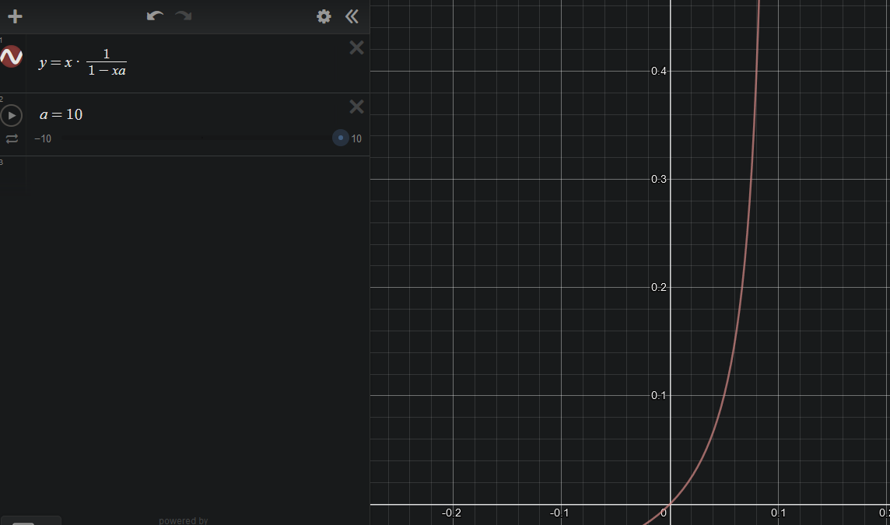

1. = + => + => + => * => * =>
2. 1. Transmission delay = $\frac{L}{R_{s}}$
   2. The second packet would be queued at the second link only if there is no queueing delay, T>= +
3. 1. Bandwidth delay = bandwidth * round trip time =>

2*10^6 $\frac{2*10^{7}}{2.5*10^{8}}$* => 0.08 * 2*10^6 => 160000 bits

* 1. The max bits is the bandwidth delay product = 160000 bits = R $d_{prop}$

*
  2. Bandwidth delay = total bits in process before receiving an acknowledgement from transmission link.
  3. $\frac{s}{R}$ => $\frac{2.5*10^{8}}{2*10^{6}}$ => 125m per bit

yes its longer than a 100m football field

* 1. meters per bit
  2. $d_{prop}$ = $\frac{3.6*10^{7}}{2.4*10^{8}}$ => 0.15 seconds
  3. 1*10^7 * 0.15s => 1500000 bits
  4. 60 * 10^7 = 600000000 => 1 per minute

1. 1. Time to send from host to first packet switch = $\frac{8*10^{6}}{2*10^{6}}$ = 4 seconds

4*3hops = 12 seconds

* 1. => 10000/2*10^6 => 0.005 =>

5 milliseconds for first packet to first switch

5*2 = 10 milliseconds for second packet from host to source

* 1. Time to send the first packet to the first switch multiplied by the number of switches there are multiplied by how many packets.

5*3 = 15 milliseconds + remaining packets * one link time =>

4010 = 4.01 seconds which is a little over a third of the time compared to (a)

* 1. Better tracking because of multiple acknowledgments from each switch.
  2. More to keep track of, multiple acknowledgements and more possibilities of packet loss.

1. $\frac{80+s}{R}$*3 + $\frac{F}{s-1}$ ($\frac{80+s}{R}$) => $\frac{d}{ds}$ $\frac{80+s}{R}$ ($\frac{F}{s}+2$) + $\frac{80+s}{R}$ $\frac{d}{ds}$ ($\frac{F}{s}+2$) => ($\frac{F}{s}+2$)(0+ $\frac{1}{R}$)+($\frac{80+s}{R}$)($\frac{-F}{s^{2}}+0$) => ($\frac{F+2s}{s}$)($\frac{1}{R}$)+($\frac{80+s}{R}$)($\frac{-F}{s^{2}}$) => ($\frac{F+2s}{sR}$)-($\frac{80+s}{R}$)($\frac{F}{s^{2}}$) => $\frac{sF+2s^{2}-80F-sF}{Rs^{2}}$ => 2s^2-80F => 2s^2 = 80F => s =



$\sqrt{40F}$

| Site | IP | 10 Ave RTT | 5 Ave RTT |
| --- | --- | --- | --- |
| google.com | 216.58.217.46 | 11ms | 12ms |
| twitter.com | 104.244.42.129 | 28ms | 28ms |
| Baidu.com  (chinese) | 220.181.38.148 | 186ms | 186ms |
| Webgerman.com  (german) | 173.236.155.48 | 104ms | 104ms |

Changing the 10 to 5, reduces the number of pings to the server from 10 to 5, making the average slightly different in some cases.

| Hop No. | Source IP Address | Destination IP Address | Round Trip Time (RTT) |
| --- | --- | --- | --- |
| 1 | 192.168.1.213  (home) | 192.168.1.1 | <1ms |
| 2 | 192.168.1.1 | 100.64.14.1 | <1ms |
| 3 | 100.64.14.1 | 199.58.99.129 | 3ms |
| 4 | 199.58.99.129 | 199.58.99.10 | 4ms |
| 5 | 199.58.99.10 | 216.110.193.44 | 22ms |
| 6 | 216.110.193.44 | 72.14.217.83 | 27ms |
| 7 | 72.14.217.83 | 72.14.217.82 | 12ms |
| 8 | 72.14.217.82 | 108.170.245.97 | 11ms |
| 9 | 108.170.245.97 | 74.125.253.61 | 14ms |
| 10 | 74.125.253.61 | 216.58.217.46 | 12ms |

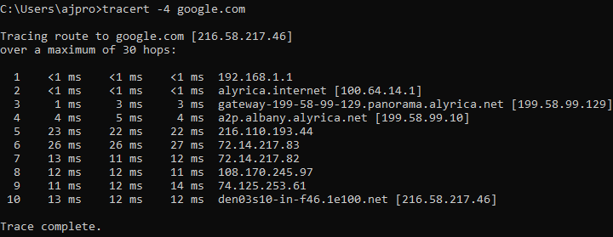

* 1. The IP is from the first hop destination, it is the router. The second IP is from the second hop destination, this is the modem.

